SECTION KG

COOLANT THERMOSTAT

CONTENTS

|  |  |
| --- | --- |
|  | Chapter |
| General Description .. | 1 |
| Removal | 2 |
| Inspection, and Testing of Thermostat Element | 3 |
| Fitting.. | 4 |

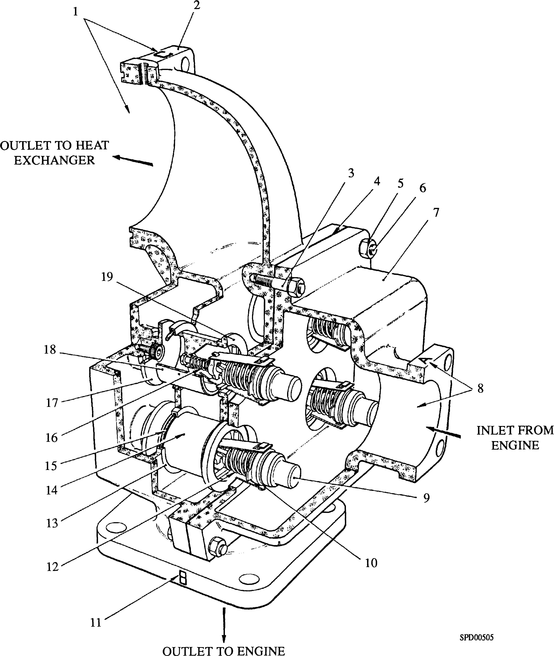

Key To Numbers

|  |  |  |  |
| --- | --- | --- | --- |
| 1. | 'C', Coolant outlet to heat exchanger | 11. | 'B', Coolant outlet to engine |
| 2. | Upper housing | 12. | Return springs |
| 3. | Stud | 13. | 'O’ ring carrier |
| 4. | Gasket | 14. | Bleed hole |
| 5. | Nut | 15. | 'O' ring |
| 6. | Setbolt | 16. | Overtravel spring |
| 7. | Lower housing | 17. | Disc seat |
| 8. | 'A', Coolant inlet from engine | 18. | Sliding sleeve |
| 9. | Thermostat element | 19. | Spider seat |
| 10. | Side strap |  |  |

Fig KG.l Coolant Thermostat

CHAPTER 1

GENERAL DESCRIPTION

1. The coolant thermostat is incorporated into the engine cooling system to ensure a rapid rise to operating temperature after the engine has been started, also to regulate coolant flow through the engine and heat exchanger circuits to maintain the coolant outlet temperature from the engine within nominal pre-set figures according to the element rating.
2. The thermostat assembly, consisting of four individual thermostat elements built into a dual purpose housing/pipe 'T', is integral to the cooling pipework system. When closed the elements (Fig KG.2) ensure that coolant within the engine closed circuit is re-circulated through the engine only, and therefore rapidly reaches normal operating temperature. At this point the thermostat elements automatically operate to maintain the engine at optimum working temperature, by regulating the coolant flow through the engine and heat exchanger circuits.
3. A small bleed hole (14)(Fig KG.l) drilled in the wall of sliding sleeve (18) equalises the pressure within both circuits, and avoids any possibility of trapped hot air pockets, or pressure surge from the engine circuit as the valve sleeve begins to lift off spider seat (19).
4. Coolant from the engine enters the coolant thermostat through inlet port 'A' (8), and whilst the engine is cold is discharged through port 'B' (11) back to the engine. As the temperature of the coolant rises, thermostat element (9) expands and lifts sliding sleeve (18) off spider seat (19), until at the maximum operating temperature it is hard against disc seat (17) and all coolant is diverted through port ’C' (1) to the heat exchanger. Any additional expansion of the element due to a further rise in temperature is absorbed by overtravel spring (16). 'O' ring (15) and 'O' ring carrier (13) are fitted at the partition of the chambers to prevent leakage of coolant between the separate passages and to provide a bearing for sliding sleeve (18). When the temperature of the coolant falls the thermostat element contracts, return springs (12) pulling the sliding sleeve towards spider seat (19).

CHAPTER 2

REMOVAL

NOTE The operating temperature of the thermostat element is factory pre­set and is not adjustable.

.1 In the event of failure of the elements they can be removed as follows:-

1. Isolate and drain the fresh water cooling system sufficiently to remove the complete coolant thermostat.
2. Remove the unit from the fresh water cooling system.
3. Remove nuts (5) and spring washers from studs (3) and setbolts (6) securing lower housing (7) to upper housing (2).
4. Lift out the four individual element assemblies and store in a safe place.
5. Remove and discard used 'O' rings from carriers.

CHAPTER 3

INSPECTION AND TESTING OF THERMOSTAT ELEMENT

NOTE Sliding sleeve (18), should start to lift off spider seat (19) at 2.8°C (5°F) below the nominal temperature rating stamped on element side strap (10), and should be fully lifted at 5.6°C (10°F) above the nominal rating.

1. To check that an element assembly is functioning correctly proceed as follows:-
2. Prepare a container of water at a temperature which is 5.6°C (10°F) below the nominal rating of the element to be tested.
3. Immerse the element in prepared water and stir the water vigorously with the element for five minutes. At the end of this period check that sliding sleeve has not lifted off spider seat (19).
4. Raise the temperature of the water to 8.3°C (15°F) above the nominal temperature of the element.
5. Immerse the element and stir vigorously for five minutes. The element should now be fully stroked. This may be checked by quickly inserting the element assembly into the upper housing and pushing the spider seat fully into its counterbore. If the spring action of the overtravel spring can be felt, the element is fully stroked. This procedure must be carried out quickly before the element can change its temperature.

NOTE Do not use oil to check the element

1. Check disc seats (17) for erosion, renew disc seats if worn.
2. Check the 'O' ring carrier for wear on the inner diameter, renew carrier if worn.

NOTE DO NOT remove the disc seats or the 'O' rings carriers except to renew.

1. Check spider seat (19) for erosion, renew thermostat element assembly if worn.
2. Check for erosion within the housing, if in doubt regarding serviceability renew the

housing.

CHAPTER 4

FITTING

NOTES 1 The following procedure is based on the assumption that the  
coolant thermostat has been completely dismantled.

2 All joints and 'O' rings must be fitted dry.

1. Press new disc seats (17) into position in upper housing (2), use an angled illuminated mirror to verify that they are fully bedded.
2. Press new 'O' ring carriers (13) into position. Check that the carriers are seating correctly before fitting new 'O' rings.
3. Check that replacement element assemblies are of the correct type.

[The nominal temperature rating is stamped on element side strap (10)].

1. Centralise new 'O’ rings (15) in their carriers (13), and put a light smear of grease around the top of sliding sleeves (18) to facilitate their entry into the 'O' rings.
2. Push the assemblies into upper housing (2) so that spider seats (19) are firmly seated in their counterbore.
3. Using a new gasket (4) assemble lower housing (7) to upper housing (2) fit nuts (5) with spring washers to studs (3) and setbolts (6) and secure.
4. Using new 'O' rings assemble the coolant thermostat to the cooling system ensuring that the stamped ports 'B' and 'C' on the unit are fitted the correct way round in the cooling circuit (see Fig KG.2). Fit and secure using bolts, nuts and spring washers.

CAUTION IF THE COOLANT THERMOSTAT IS FITTED INCORRECTLY COOLANT WATER WILL BE DIVERTED THE WRONG WAY THROUGH THE FRESH WATER COOLING CIRCUITS AND MAY CAUSE SERIOUS DAMAGE TO THE ENGINE.

1. Prime and vent the cooling system, ensuring that the correct corrosion inhibitor or anti-freeze is mixed with any fresh coolant added to the system (see Section KA).

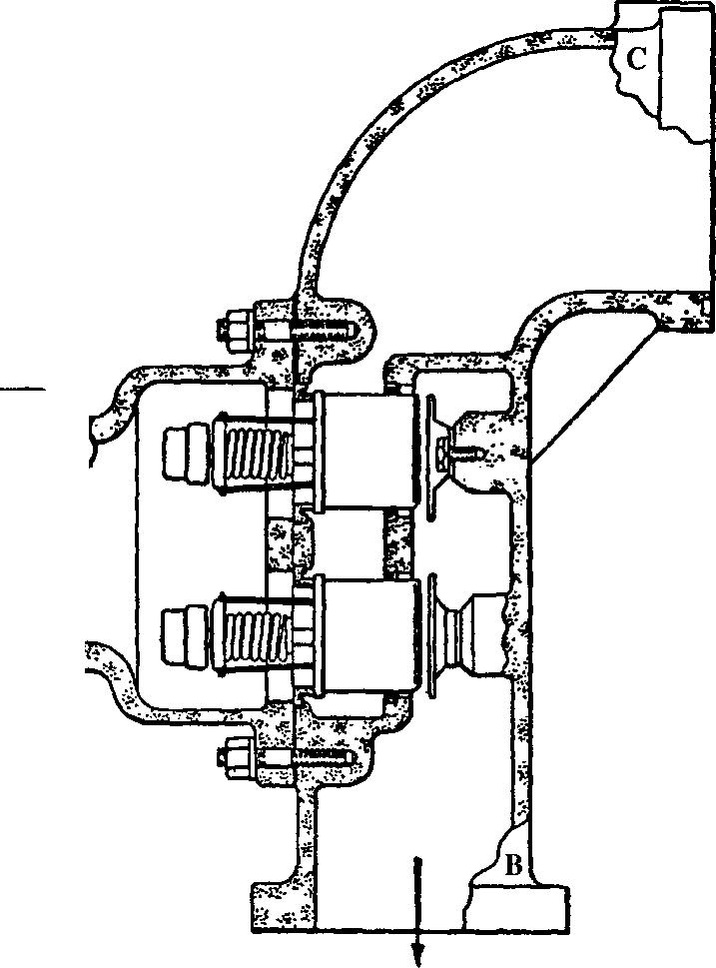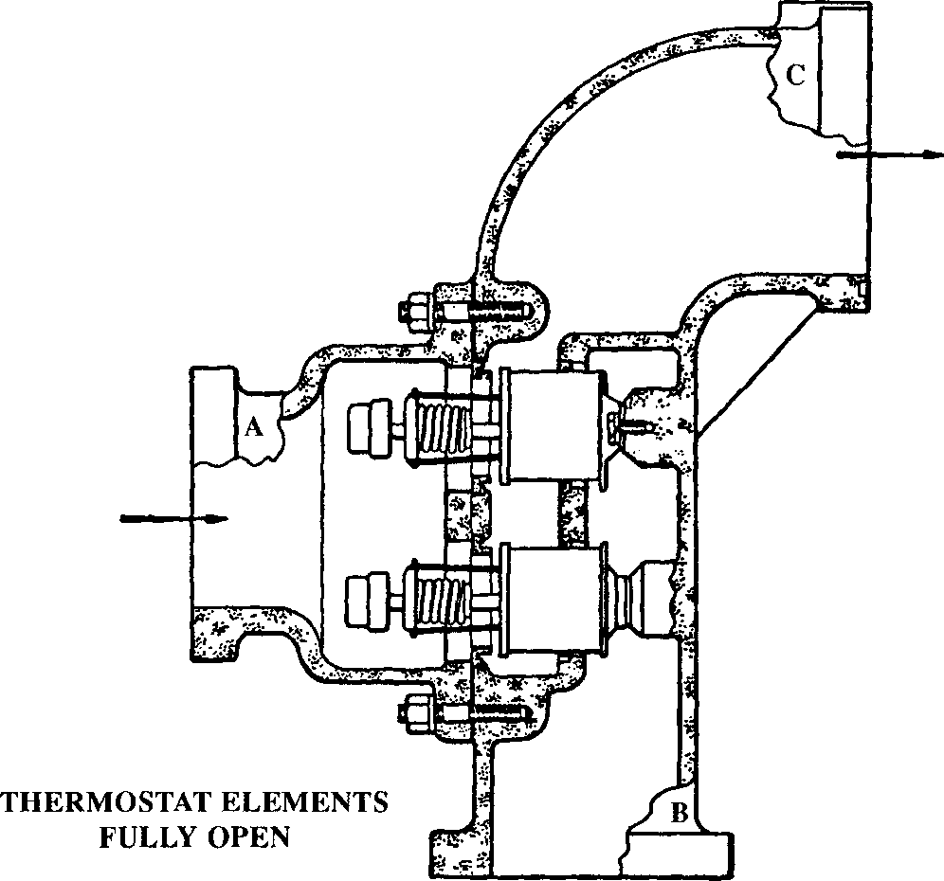

|  |  |
| --- | --- |
|  | D2 |
|  |  |
|  |

**THERMOSTAT ELEMENTS  
CLOSED**

Fig KG.3 Operation of thermostat elements and coolant thermostat

COOLANT

THERMOSTAT

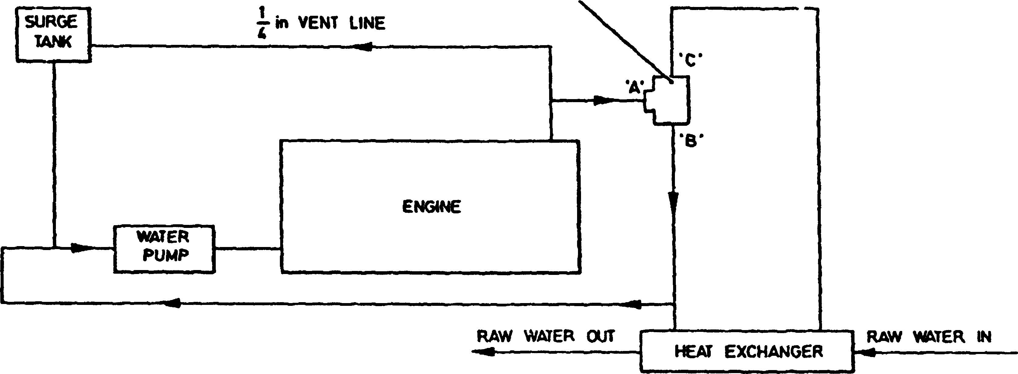

STAGE 1. COOLANT FLOW WITH THERMOSTAT — BELOW NOMINAL TEMPERATURE RATING

COOLANT

THERMOSTAT

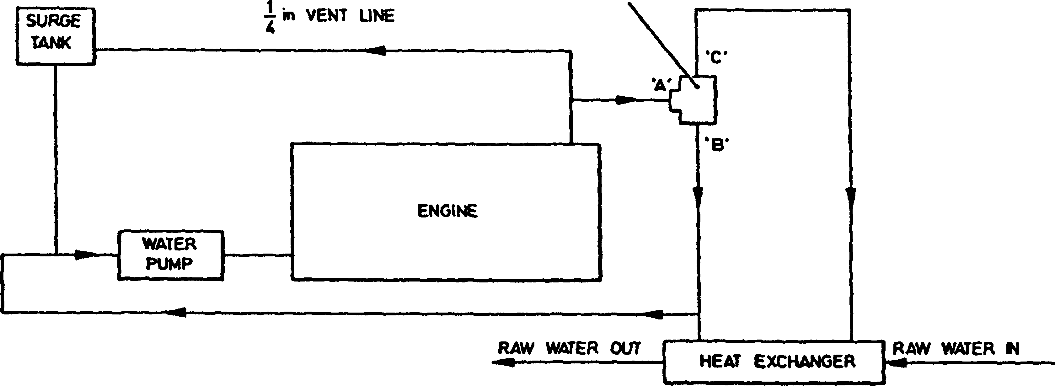

STAGE 2. COOLANT FLOW WITH THERMOSTAT — AT OPERATING TEMPERATURE

COOLANT

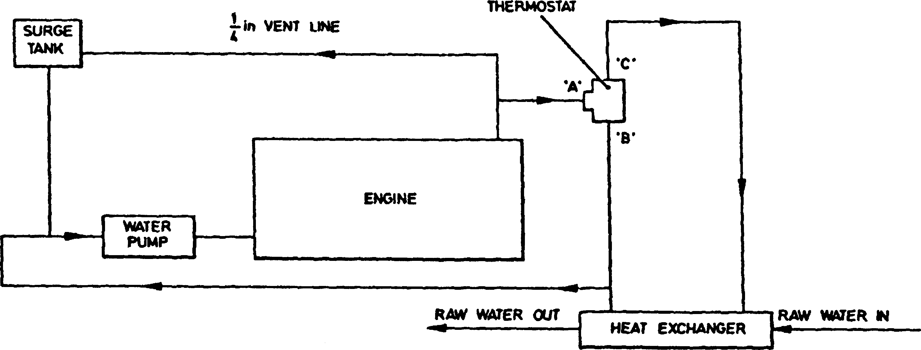

STAGE 3. COOLANT FLOW WITH THERMOSTAT — ABOVE NOMINAL TEMPERATURE RATMG

Fig KG.3 Diagrammatic of coolant flow